Programming 1

Tutorial 1

# Activity 1

Install Notepad++, IntelliJ IDEA and AdoptOpenJDK Hotspot 1.8

Add JDK to Path environment variable.

Test javac command.

# Activity 2

HelloWorld is the program which prints out the text “Hello, world!”. Write, compile and run the HelloWorld program using Notepad++ and CMD only. Next, compile and run the HelloWorld program using the IDE, which is IntelliJ IDEA.

Note that you will have to create a Java project in IntelliJ IDEA for this exercise. Many Java programs can be created in a project. Therefore, it is advisable to create as few projects as possible to avoid littering your IDE with small, temporary projects.

# Activity 3

Edit the following program so that it shows your personal information, then run the program twice using both CMD and IDE.

public class Greeting {

public static void main(String[] args) {

String myName = "Your name here";

String mob = "March"; // month of birth

int yob = 2001; // year of birth

String intro = "I'm from Hanoi. I went to ... school, etc";

System.out.println("Hi, my name is " + myName + ".");

System.out.println("I was born in " + mob + ", " + yob + ".");

System.out.println(intro);

}

}

# Activity 4

The System.out.println() statement can output an arithmatic expression. Your age can be calculated by substracting your birth year from the year 2021. For example, if you’re born in 2002, then your age should be 2021 – 2002. Write a program, named PrintMyAge, to calculate and print your age. Run the program using both CMD and IDE.

## Sample result

I was born in 2002. This year is 2021.

Therefore, my age is:

19

# Activity 5

Given an amount of money in VND, such as 1,200,000 VND, and the exchange rate of 207 VND to 1 JPY. Write a simple Java program to calculate and display the amount of equivalent JPY for a given amount of VND. The program needn’t use variables. Run the program using both CMD and IDE.

## Sample result

The amount of JPY for 1,200,000 VND is:

5797

# Activity 6

The area of a triangle can be calculated from its base *b* and height *hb*. Write a simple Java program to calculate and display the area of a triangle from its base and height value. The program needn’t use variables. Run the program using both CMD and IDE.

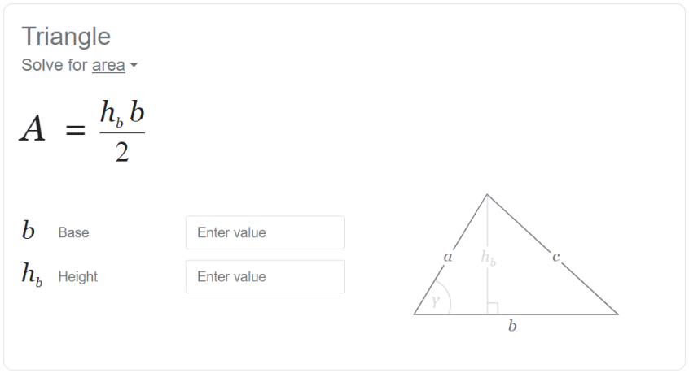

## Sample result

The triangle's base is 3 (cm) and height is 1.5 (cm).

Its area (cm2) is:

2.25

# Submission

Submit a **zip** file containing all Java programs to this tutorial’s submission box in the course website on FIT Portal.